# Summary

ACM, GITAM had conducted the "DSA Engage" event. In this event, ACM collaborated with one of the best online learning platform i.e. Coding Ninjas. The speaker of the event was Swapnil Narayan(Software engineer at Microsoft). The event started with an introduction speech by Swapnil Narayan sharing his insights regarding DSA. The event was organized on 05/02/2022 from 11:00 AM to 1:00 PM on Zoom, and the participants interacted with the speakers through the Zoom platform.

The publicity and registrations for the event started seven days before the event, and students were sent the event's details through the club's official mail id. A WhatsApp message was also circulated briefing about the event, and all the details of the event were mentioned there. The posters and videos regarding the event were shared on various social media handles such as Instagram and LinkedIn. Whatsapp groups were created to engage with the participants. 92 attended the webinar.

By the end of the event, experts in technological domain addressed the participants on various aspects of application of data structures. This event enlightened the attendees about the role of data structures and algorithms in the day-to-day life of an engineering student. The speakers interacted with the participants by posing some questions on daily life problems and related them to the concepts of DSA. The event helped the participants to improve their analytical skills as they are a useful tool to pick out the underlying algorithms in real-world problems and solve them efficiently. Attendees appreciated the event, and the event was a great success.

# Photographs

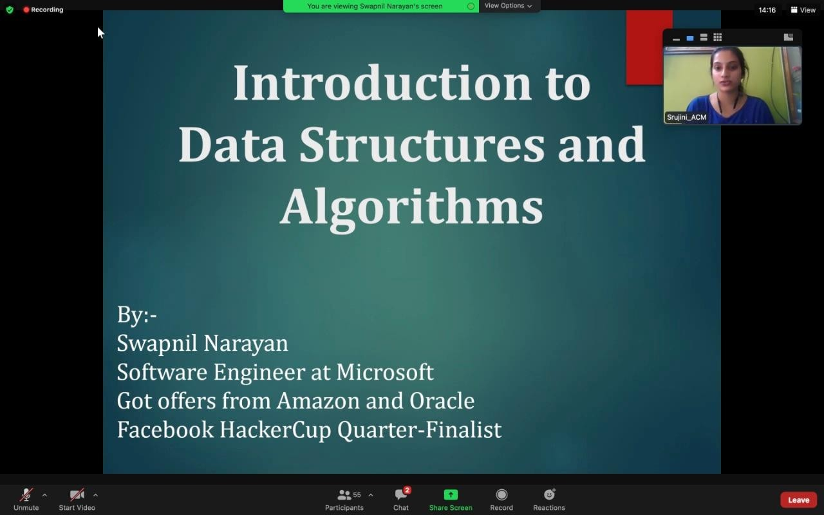

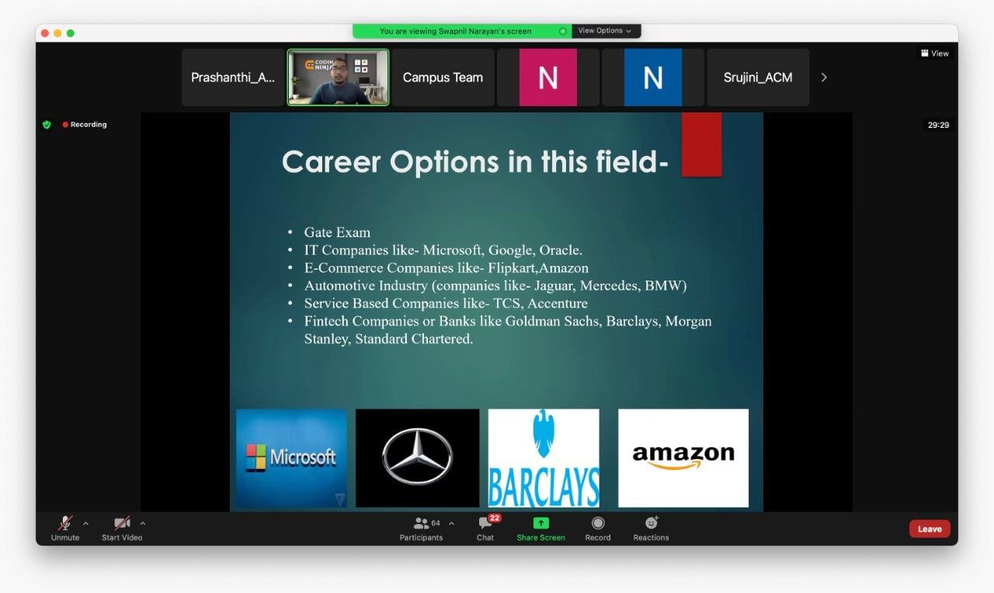

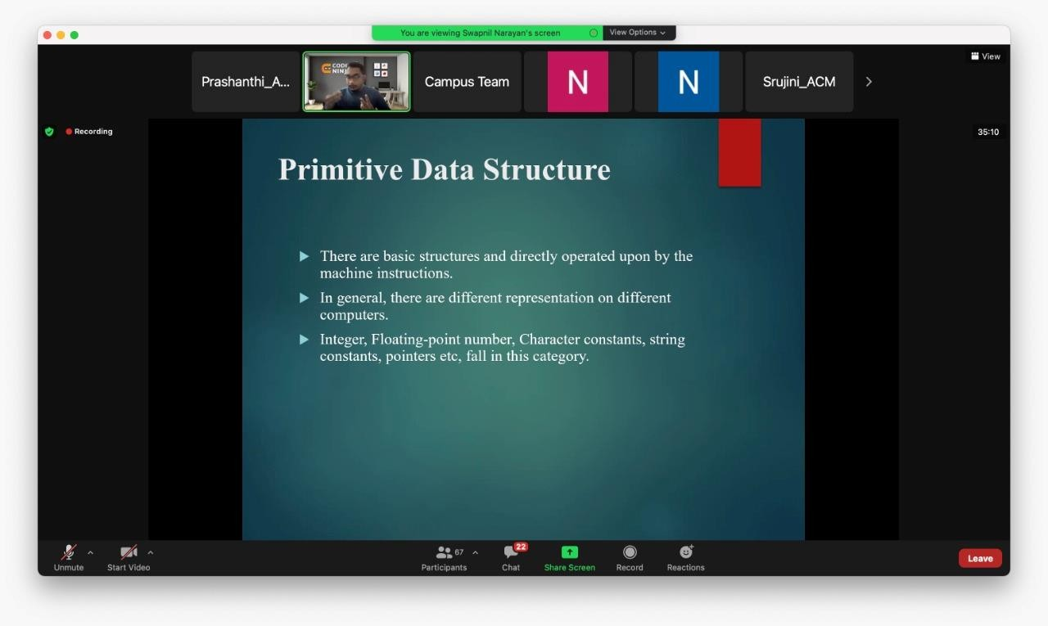

Event Snapshot

|  |  |
| --- | --- |
| **EVENT SNAPSHOT** | |
| Event Name: | DSA Engage |
| Organizing Club: | ACM |
| Event Date: | 05/02/2022 |
| Event Time: | 11:00 AM to 1:00 PM |
| Event Mode / Venue: | Online / Zoom |
| Social media reach: | Instagram: @gitam_acm  LinkedIn: https:/[/www.linkedin.com/company/acm](http://www.linkedin.com/company/acm)  -gitam-association-for-computing- machinery/mycompany/ |
| Registrations: | 110 |
| Number of Participants/Attendees: | 92 |
| Winners (if any): Name - Regd ID - Email ID | NA |
| Faculty - Judge - Guest Speaker: | Swapnil Narayan(Software engineer at Microsoft) |
| Event Report Author - Designation: | Prashanthi - Event Management Lead, ACM, Gitam.  Vaibhav- Secretary, ACM Gitam |